 | 12.1.30 Editors - Geometry Nodes Editor - Header - Add Menu - Mesh
Table of content
Detailed table of content 1
Add menu - Mesh - Write 3
Set Face Set – Tool Mode 3
Set Mesh Normal 3
Set Shade Smooth 5

Detailed table of content
Detailed table of content
Detailed table of content 1
Add menu - Mesh - Write 3
Set Face Set – Tool Mode 3
Input 3
Mesh 3
Selection 3
Outputs 3
Mesh 3
Set Mesh Normal 3
Input 3
Mesh 3
Selection 4
Shade Smooth 4
Properties 4
Sharpness Mode 4
Sharpness 4
Free 4
Domain 4
Tangent Space 4
Inputs 4
Sharpness 4
Remove Custom 4
Edge Sharpness 4
Face Sharpness 5
Free/Tangent Space 5
Custom Normal 5
Outputs 5
Geometry 5
Set Shade Smooth 5
Input 5
Geometry 5
Selection 5
Shade Smooth 5
Properties 6
Domain 6
Edge 6
Face 6
Outputs 6
Geometry 6

Add menu - Mesh - Write
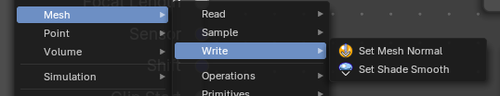
These are nodes for working with Mesh data.

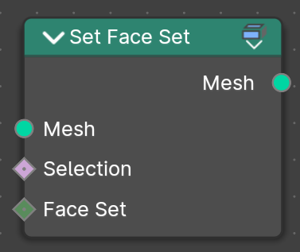
Set Face Set – Tool Mode
Set sculpt face set values for faces based on a selection and face set ID, for tool execution.
This node is only available in the Tool Mode for Node Group Tools assets.

Input

Mesh
Geometry Input mesh.

Selection
A selection of the input mesh,

Outputs

Mesh
Geometry output mesh.

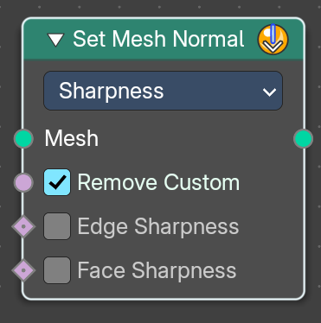
Set Mesh Normal
The Set Mesh Normal node is used to modify custom normals on a mesh, providing control over shading smoothness and surface appearance. This is useful for adjusting normal smoothness, sharp edges, and tangent-based effects

Input

Mesh
Input mesh.

Selection
A selection of the input mesh.

Shade Smooth
Set the shading to smooth.

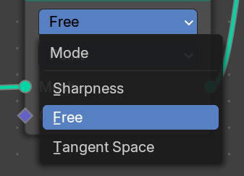
Properties

Sharpness Mode

Sharpness
Controls the intensity of edge sharpness. Higher values create stronger shading contrasts between faces.
Store the sharpness of each face or edge. Similar to the "Shade Smooth" and "Shade Flat" operators.

Free
Allows direct manipulation of normals as free vectors, rather than constrained by geometry. Useful for custom shading effects and non-destructive normal adjustments.

Domain
Attribute domain to store the free custom normals.
- Point
- Face
- Face Corner

Note: Default object normals are stored to Facecorner, this will “pass-through” the normal data. Face normals will make “flat” sharp edges.

Tangent Space
Adjusts normals relative to the surface tangent to store the source meshes normals. Stores normals in a deformation dependent custom transformation space.
Note: This method is slower, but can be better when subsequent operations change the mesh without handling normals specifically.

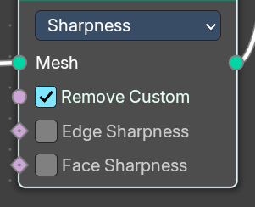
Inputs

Sharpness

Remove Custom
Removes custom normals previously set by the user on the original mesh data when enabled.

Edge Sharpness
Sets the normal sharpness to the edge domain to “flat”.

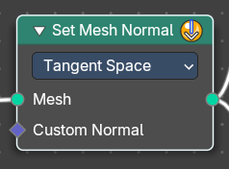
Face Sharpness
Sets the normal sharpness to the face domain to “flat”.

Free/Tangent Space
These properties are the same in Free and Tangent mode.

Custom Normal
Vector Field based on the normal.
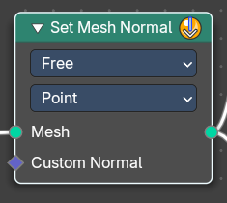

Outputs

Geometry
Geometry output.
Got it! Here's the documentation for the Set Mesh Normal node:

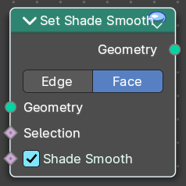
Set Shade Smooth
Retrieves if the geometry is shaded smooth.

Input

Geometry
Input mesh.

Selection
A selection of the input mesh.

Shade Smooth
Set the shading to smooth.

Properties

Domain

Edge
Set Edge to smooth.

Face
Set Face to smooth

Outputs

Geometry
Geometry output.

